**HOTEL GRAND EFE** 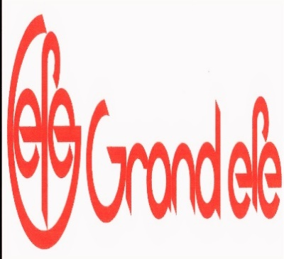

**ALL INCLUSIVE CONCEPT**

**10.00 – 23.00**

|  |  |  |
| --- | --- | --- |
| MEALS --- RESTAURANT |  |  |
| BREAKFAST | OPEN BUFFET / SELF SERVİCE | 07:00 - 10:00 |
| LUNCH | OPEN BUFFET / SELF SERVİCE | 12:30 - 14:00 |
| DINNER | OPEN BUFFET / SELF SERVİCE | 19:00 - 21:00 |
| DRİNKS- BEVERAGES | SOFT & LOCAL BEVARAGES SODA-WATER-BEER-WINE |  |

|  |
| --- |
| **HOT DOG ---- T AVERNA BAR**  **14.00 – 15.00** |
| POMMES FRITES – HOT DOG |

|  |
| --- |
| **PİZZA ----- TAVERNA BAR 15.00 - 16.00** |
| PIZZA |

|  |
| --- |
| **BEVERAGES---**  **LOBBY BAR – TAVERNA BAR**  **10:00 - 23:00** |
| * SOFT DRINKS = COLA- FANTA- CONCENTRATED DRINKS– MINERAL WATER- TEA- CAFEE- WATER- MILK- ESPRESSO- CAPPUCCINO |
| * LOCAL ALKHOL = DRAUGHT BEER- WINE– GIN– VODKA- RAKI – COGNAC- LIQUER |

|  |
| --- |
| **MİNİ BAR ---- SMALL WATER 0,50 LT** |

|  |
| --- |
| ACTIVITIES – OUR FREE SERVICES |
| SAFE BOX IN ROOM |
| WIRELESS INTERNET CONNECTION |
| BEACH TOWELS, UMBRELLA, SUNBEDS, MATRESS FOR SUNBEDS |
| TENNIS, BASKETBALL, MINI GOLF, PING PONG, DART, BEACH VOLLEY, POOL SPORTS |
| SOFT ANIMATION, MINI CLUP, DISCO, |
| OKEY GAME, BACKGAMMON, PLAYYING CARDS |
|  |

### SERVICES NOT INCLUDED IN ALL INCLUSIVE CONDITIONS

|  |  |  |
| --- | --- | --- |
| IMPORT DRINKS, FRESH JUICE, TURKISH COFFEE, BOTTLE BEVERAGES (BEER,WINE ETC.) ICE CREAM | IN ALL BARS | EXTRA |
| MARKET, SOUVENIR SHOP, BOUTIQUE |  | EXTRA |
| ROOM SERVİCES, LAUNDRY SERVICES |  | EXTRA |
| DOCTOR, PHOTOGRAPH, HAIR DRESSER |  | EXTRA |
| TELEPHONE |  | EXTRA |
| GAME CENTER |  | EXTRA |
| HAMAM, SAUNA, MASSAGE | 10:00 – 19:00 | EXTRA |
| WATER SPORTS | BANANA, WATER SKI, RINGO,PARASAILING | EXTRA |

THE HOTEL MANAGEMENT KEEPS ALL RİGHTS TO CHANGE MEAL TIMES AND OTHER CONDITIONS DUE TO SEASONAL CONDITIONS

**HOTEL C/IN TIME IS BETWEEN 14.00 AND 16.00 THE C/OUT TIME IS 12.00 O’CLOCK**

**BREAKFAST IS PAYABLE FOR EARLY C/IN**

**ROOM EXTENSION FEES ARE DEFINED ACCORDING TO SEASON PRICES AND AVAILABILITY**

**TO EXTEND ALL INC CONCEPT IS PAYABLE**